SECURE FILE SHARING
Report Submitted to
Department of Artificial Intelligence and Machine Learning
In partial fulfilment of the requirements for the degree of

BACHELOR OF SCIENCE IN ARTIFICIAL INTELLIGENCE AND MACHINE LEARNING
by

MARAN (REG.No.2428C0152)
Under the Guidance of

Mr.N.NAVEEN KUMAR



Department of Artificial Intelligence and Machine Learning

ADITHYA COLLEGE OF ARTS AND SCIENCE
(Affiliated to Bharathiar University)
Kurumbapalayam, Sathy Road,
Coimbatore-641 107

MARCH 2026

SECURE FILE SHARING
Report Submitted to
Department of Artificial Intelligence and Machine Learning
In partial fulfilment of the requirements for the degree of

BACHELOR OF SCIENCE IN ARTIFICIAL INTELLIGENCE AND MACHINE LEARNING
by

MARAN (REG.No.2428C0152)
Under the Guidance of

Mr.N.NAVEEN KUMAR

Department of Artificial Intelligence and Machine Learning

ADITHYA COLLEGE OF ARTS AND SCIENCE
(Affiliated to Bharathiar University)
Kurumbapalayam, Sathy Road,
Coimbatore-641 107

MARCH 2026

CERTIFICATE

CERTIFICATE

This is to certify that the project work entitled “ FIRE DETECTION SYSTEM USING AURDINO IOT " submitted to the Bharathiar University in partial fulfilment of the requirements for the award of the Degree of BACHELOR OF SCIENCE IN ARTIFICIAL INTELLIGENCE AND MACHINE LEARNING is a record of original project work done by SHRIRAM.R (Reg.No. 2428C0152) during the period December 2025 – March 2026 of his study in the Department of Artificial intelligence and Machine Learning ADITHYA COLLEGE OF ARTS AND SCIENCE, COIMBATORE, affiliated to Bharathiar University, under my supervision and guidance and the project work has not formed the basis for the award of any degree or other similar title to any candidate of any University
.

Signature of the Guide

Signature of the Principal

Submitted to Viva Voce examination on ______________

Signature of the Internal Signature of the External
Examiner Examiner

ACKNOWLEDGEMENT

ACKNOWLEDGEMENT

I would like to express my sincere gratitude and appreciation to all the individuals and authorities who have contributed towards the successful completion of this project.
Firstly, I extend my heartfelt thanks to Er. C. Sukumaran, Chairman Adithya Institutions, whose unwavering support, leadership, and vision have guided us through the duration of this project. His valuable advice and encouragement have been a constant source of motivation.
My sincere thanks go to Mr. S. Praveen Kumar, Managing Trustee, Adithya Institutions, for his consistent encouragement and belief in the project's potential. His guidance has been a key factor in the development and success of this initiative.
I would like to express my gratitude to Dr. K. Srinidhi, Trustee, Adithya Institutions, for her constant support. Her leadership and commitment to excellence have set a standard for us all to follow.
A special note of thanks to Dr. R. Anuja, Principal, Adithya College of Arts and Science, for providing us with the necessary resources and opportunities to work on this project. Her academic insight and support have been essential in ensuring the smooth progress of our work.
I am deeply grateful to Mr.N.Naveen Kumar, guide and Assistant Professor, Adithya College of Arts and Science, for his continuous guidance, encouragement, and invaluable expertise. His mentorship has played an indispensable role in shaping this project, and I have learned much under his Supervision.
Finally, I would like to acknowledge the support and cooperation of all faculty members, staff, and my fellow students who have been instrumental in the successful completion of this project.

SHRIRAM.R

DECLARATION

DECLARATION

I, hereby declare that the project work entitled “ FIRE DETECTION SYSTEM USING AURDINO IOT” submitted to the Bharathiar University in partial fulfilment of the requirements for the award of the degree of BACHELOR OF SCIENCE IN ARTIFICIAL INTELLIGENCE AND MACHINE LEARNING is a record of original and independent research work done by me during period December 2025 – March 2026 under the supervision and guidance of Mr.N.Naveen Kumar Assistant professor of computer science, ADITHYA COLLEGE OF ARTS AND SCIENCE and that it has not formed the basis for the award of any Degree or other similar titled to any candidate of any University.
.

Signature of the Candidate

TABLE OF CONTENTS

S.NO | CONTENTS |  | PAGE NO
1 | INTRODUCTION |  | 3
1 | 1.1 | SYSTEM SPECIFICATION | 4
1 | 1.1.1 | HARDWARE CONFIGURATION | 4
1 | 1.1.2 | SOFTWARE SPECIFICATION | 5
2 | SYSTEM STUDY |  | 7
2 | 2.1 | EXISTING SYSTEM | 7
2 | 2.1.1 | DRAWBACKS | 8
2 | 2.2 | PROPOSED SYSTEM | 9
2 | 2.2.1 | FEATURES | 10
3 | SYSTEM DESIGN AND DEVELOPMENT |  | 12
3 | 3.1 | FILE DESIGN | 12
3 | 3.2 | INPUT DESIGN | 12
3 | 3.3 | OUTPUT DESIGN | 13
3 | 3.4 | SYSTEM DEVELOPMENT | 14
3 | 3.4.1 | DESCRIPITION OF MODULES | 15
4 | TESTING AND IMPLEMENTATION |  | 20
5 | CONCLUSION |  | 28
6 | BIBLIOGRAPHY |  | 30
7 | APPENDICES |  | 32
 | DATA FLOW DIAGRAM |  | 32
 | SAMPLE CODING |  | 0
 | SAMPLE INPUT |  | 0
 | SAMPLE OUTPUT |  | 0

ABSTRACT
The rapid growth of digital communication has increased the need for secure methods of transferring sensitive data. Traditional file-sharing platforms often expose users to security risks such as unauthorized access, data leakage, and misuse. To address these concerns, this project proposes Secure File Sharing, a web-based solution designed to offer a safe, user-friendly, and efficient method for uploading and sharing files. The system combines modern web technologies with strong encryption practices to ensure confidentiality and controlled access to shared data.
The application is built using a React frontend and a Python FastAPI backend, ensuring both scalability and smooth user experience. Key features of the system include secure file upload with size and type restrictions, optional AES-based encryption, and storage of configuration details through environment variables. These components help the system validate and process files safely before storing them. Its modern UI design and clear workflows make the platform accessible even to non-technical users, enhancing overall usability.
A major strength of the system is its temporary sharing mechanism, which generates short-lived sharing links and QR codes. Users can configure expiration times and download limits, ensuring that files remain accessible only for the intended duration. Encrypted files require password authentication upon download, adding an extra layer of protection. This approach helps prevent unauthorized access and minimizes long-term exposure of sensitive data.
Overall, the Secure File Sharing system demonstrates an effective integration of encryption, controlled access, and modern web technologies to produce a secure and reliable file-sharing platform. It offers a practical solution for students, professionals, and organizations seeking safe alternatives to conventional file-sharing methods. Its modular architecture also makes it suitable for further enhancement, such as database integration, cloud deployment, and advanced security monitoring, enabling it to evolve into a fully production-ready system.

INTRODUCTION

INTRODUCTION
In today’s digital era, the exchange of information has become an essential part of both personal and professional activities. People frequently share documents, images, reports, and confidential data through various online platforms. However, as file sharing grows, so do the risks associated with it—such as data theft, unauthorized access, and privacy violations. These challenges highlight the need for secure and dependable methods to share sensitive files over the internet.
Traditional file-sharing platforms usually focus on convenience rather than strong security. Many systems store data without proper encryption, keep files for long durations, or provide links that can be accessed by unintended users. As a result, confidential information is at risk of exposure. This situation is especially problematic for students, professionals, and organizations that regularly share important documents. Therefore, there is a clear need for a dedicated system that prioritizes data protection while still offering ease of use.
The Secure File Sharing project aims to address these issues by providing a platform that ensures safe, controlled, and temporary sharing of files. The system integrates modern web technologies with strong encryption techniques to protect user data during upload, storage, and download. By combining simplicity with robust security features, the platform aims to give users confidence that their files are shared only with the intended recipients.
One of the key advantages of this system is its ability to limit access to shared files. Users can set expiration times, restrict the number of downloads, and optionally secure files with a password. These features help ensure that files are not accessible beyond the required duration and reduce the chances of unauthorized retrieval. The system also includes a clean and user-friendly interface, making it easy for anyone to upload, manage, and share files without technical difficulties.
Overall, the Secure File Sharing project demonstrates the importance of combining convenience with strong security in modern file-sharing solutions. By offering controlled access, encryption, and temporary sharing options, the system provides a practical and reliable way to exchange sensitive information. It serves as a useful tool for academic, personal, and professional use, and lays the foundation for future enhancements such as cloud deployment, database integration, and advanced monitoring features.

1.1.SYSTEM SPECIFICATION
The Secure File Sharing system runs on standard lab or personal machines (dual-core CPU, 8 GB RAM, ~10 GB free disk), with a React (TypeScript) frontend and a Python FastAPI backend; development requires Node.js v14+ and Python 3.8+, while production is recommended on a VPS/on-prem server (2–4 vCPU, 4–8 GB RAM, SSD, HTTPS enabled) behind a reverse proxy (Nginx/Apache) exposing ports for the web UI (3000) and API (8000). The client–server architecture provides a responsive UI for drag-and-drop uploads, file listing/management, and share-link/QR generation; the backend exposes RESTful JSON endpoints for upload, list, delete, link creation, and secure download, applies optional AES encryption using a password-derived key (PBKDF2), enforces file type/size limits, and stores configuration via .env (secret key, allowed extensions, max size, upload directory, token expiry).
Functional specs include: validated file upload, optional password-based encryption, temporary share links with configurable expiry and download limits, protected downloads (password check when encrypted), view/delete files, and active link tracking. Non-functional specs cover: security (HTTPS in production, secret management in environment variables, CORS control), reliability (clear errors and safe fallbacks), usability (clean, mobile-responsive UI), performance (streamed transfers up to configured size, e.g., 100 MB), maintainability (modular components and well-defined routes), and future scalability (database metadata, object storage like S3, background workers, and role-based access if needed).
1.1.1 HARDWARE REQUIREMENTS

Minimum Requirements
- Processor: Dual-core CPU (Intel i3 / AMD equivalent)
- RAM: 4 GB
- Storage: 2 GB free space
- Graphics: Integrated GPU
- Audio: Basic audio codec support

Recommended Requirements
- Processor: Quad-core CPU (Intel i5 / Ryzen 5 and above)
- RAM: 8–16 GB (required for faster AI model inference)
- Storage: SSD with 10+ GB free space
- GPU (optional): NVIDIA GPU with CUDA support for Whisper acceleration

1.1.2 SOFTWARE REQUIREMENTS
• Operating System: Windows 10/11, Linux (Ubuntu 20.04+), or macOS
• Programming Language: Python 3.8+
• Frameworks & Libraries:
- FastAPI / Streamlit / Flask for UI (project dependent)
- FFmpeg for audio extraction
- Standard Python libraries (os, json, pydub, etc.)

SYSTEM STUDY

2.1 EXSISTING SYSTEM

In many traditional file-sharing systems, the primary focus is on providing simple and fast methods to transfer files between users. Most commonly used platforms such as email attachments, messaging apps, and generic cloud storage services allow users to upload and share files without much technical effort. However, these platforms often lack strong security controls, leaving sensitive documents vulnerable to unauthorized access. As a result, users must rely on the security policies of third-party services, which may not always prioritize data confidentiality.
In existing systems, file sharing is usually performed through publicly accessible links or permanently stored cloud folders. These links can easily be forwarded or misused by unintended recipients. Moreover, many existing methods do not support link expiration, meaning files may remain available long after the user has stopped needing them. This increases the risk of accidental data exposure. Once a file is uploaded to such platforms, users have limited control over how long the data stays online or who can continue accessing it.
Another significant limitation of existing systems is the lack of integrated encryption. While some platforms offer basic security features, encryption is often optional, complex to configure, or not provided at all. Many users end up sharing important documents without any form of protective encryption, assuming the platform itself will provide adequate security. This creates a potential threat, especially when dealing with confidential information such as academic records, personal documents, or internal business files.
Existing file-sharing applications also struggle with providing download restrictions or usage limits. Once a file link is created, most systems allow unlimited downloads without notifying the file owner. This lack of monitoring and control makes it difficult to track file usage or detect unauthorized activity. Users also cannot easily restrict the number of times a file can be accessed, which further increases the risk of improper sharing and breaches.
From a usability perspective, many traditional systems are not optimized for controlled sharing. Users may need to navigate multiple settings or separate tools just to secure a single document. Some platforms require account creation or subscription to higher-tier plans to access security-related features. This complicates the process and discourages individuals from implementing proper file-protection measures, especially non-technical users who expect straightforward functionality.
Overall, the existing file-sharing environment lacks a focused combination of security, simplicity, and control. Users often compromise between convenience and safety, resulting in unnecessary risks.

2.1.1 DRAWBACKS

Many existing file-sharing platforms suffer from poor security measures, which expose users to the risk of unauthorized data access. Since files are often shared through open links or unprotected channels, sensitive information can be misused if it falls into the wrong hands. This lack of built-in protection forces users to depend on external tools or manual methods to secure their files, making the overall sharing process less reliable and more vulnerable.
Another drawback is the absence of proper encryption in most traditional systems. Even when encryption is available, it is usually not automatically applied or requires advanced technical knowledge to configure. As a result, many users end up sharing files in plain form without realizing the security risks involved. This creates opportunities for attackers or unauthorized individuals to intercept and misuse confidential data.
A significant limitation in current file-sharing methods is the lack of time-bound or controlled access. Once a link is generated, it typically remains active indefinitely unless manually revoked. This becomes problematic when users forget to remove access or when links get shared beyond the intended audience. Without features like link expiration or restricted download limits, users cannot effectively control how long their shared files remain accessible.
Existing systems also lack visibility and control over file usage. Most platforms do not show how many times a file has been downloaded or who has accessed it. This prevents users from monitoring their shared content and identifying possible misuse. Without audit logs or access tracking, it becomes difficult to ensure that sensitive files are being used only for their intended purpose.
Usability issues also affect many file-sharing methods. Some platforms require users to create accounts, subscribe to premium plans, or navigate through multiple security settings before sharing a single file. This complexity discourages users from applying proper protection measures. Non-technical users often prefer convenience, which can lead them to skip important security steps and unknowingly expose sensitive information.
Lastly, many existing systems depend heavily on centralized storage, making them susceptible to data breaches, server failures, and unauthorized access by internal personnel. Users have little control over how long their files are stored or how securely they are managed. This reliance on third-party servers raises concerns about data privacy and ownership, especially when dealing with personal or confidential documents.

2.2 PROPOSED SYSTEM
In the current digital environment, most file-sharing activities rely on general-purpose platforms such as email, messaging apps, and cloud storage services. These systems are designed mainly for convenience, enabling users to quickly upload and send files without any technical expertise. While this makes sharing easy, it also means that the underlying systems do not give users detailed control over how their files are accessed or protected. As a result, sensitive data often moves through channels that were not specifically built with security as the primary goal.
Traditional file-sharing platforms typically generate open or semi-public download links. These links can be forwarded to anyone, intentionally or accidentally, and the original uploader has no clear way to restrict access once the link is shared. This becomes a major issue when users handle confidential documents such as personal IDs, financial data, project files, or internal organizational material. The lack of granular control means that once a file is uploaded, it can circulate indefinitely without the owner’s awareness.
Another limitation in existing systems is the minimal use of encryption. Although some services offer encrypted storage, encryption is not always enforced, and in many cases it is not applied to the sharing process itself. Files may be stored securely but still transmitted through unprotected links. Many users are unaware of this distinction, and because encryption options are often hidden or complicated, they end up sharing documents without proper protection. This creates an opportunity for unauthorized interception or misuse.
Most existing platforms also do not provide time-bound or temporary sharing features. Once a file is shared, it usually remains accessible until manually deleted by the user, which many people forget to do. This prolonged accessibility increases the risk of old links resurfacing or being accessed by unintended users. Without automatic expiration features, the responsibility for secure access management falls entirely on the user, which is not always practical or reliable.
Furthermore, many conventional file-sharing systems provide limited visibility into how shared files are being used. Users cannot see how many times a file has been downloaded, who accessed it, or whether the link has been misused. This lack of transparency makes it impossible to monitor access patterns or detect suspicious activity. As a result, users may remain unaware of unauthorized downloads or data leakage until it is too late.
Overall, the existing systems available for file sharing are primarily built for convenience rather than security. They do not offer features like strong encryption, temporary access links, QR-based secure sharing, or download-limit controls.
2.2.1. FEATURES
The Secure File Sharing system provides a safe and reliable platform for uploading, storing, and sharing files. One of its core features is secure file upload, where users can easily drag and drop files or select them manually. The system checks file types and sizes before accepting them, ensuring that only valid and safe files are processed. This prevents unnecessary storage of harmful or incompatible files and maintains the overall integrity of the platform.
A standout feature of the system is its optional AES-based file encryption. When uploading a file, users may choose to protect it using a password. The system encrypts the file before storing it, ensuring that even if unauthorized users access the backend storage, the content remains unreadable. This gives users strong control over the privacy of their documents and adds a powerful layer of security to sensitive information.
The system also supports temporary share links, which are automatically generated for each shared file. These links come with customizable expiration times and download limits. Users can decide how long a file should remain accessible and how many times it can be downloaded. This prevents long-term exposure and reduces the risk of unauthorized access once the intended purpose of sharing is fulfilled. The temporary link mechanism makes the file-sharing process flexible and secure.
To make sharing even more convenient, the platform features QR code generation for shared links. Instead of typing or copying long URLs, users can simply scan a QR code using any smartphone to access the shared file. This is especially useful in academic and corporate environments where file transfers happen frequently during meetings, labs, or presentations. QR-based sharing ensures quick access without compromising security.
Another important feature is the file management dashboard. Users can view all their uploaded files, check their details, and delete them whenever needed. The dashboard helps users stay organized and maintain control over their stored content. It also displays information such as encryption status, how many times a file has been downloaded, and whether a link is still active, enabling users to monitor their shared data.
Lastly, the system includes essential backend security measures such as CORS protection, environment-based configuration for secret keys, and controlled access to the uploads directory. These features ensure that the platform remains safe from common security threats and operates smoothly across different devices. Together, all these features make the Secure File Sharing system a modern, secure, and user-friendly solution for exchanging files efficiently.

SYSTEM DESIGN AND DEVELOPMENT

3.1 FILE DESIGN
The file design of the Secure File Sharing system focuses on organizing and managing user-uploaded files in a structured and secure manner. Since the system handles sensitive documents, the file storage layout ensures that all uploaded content is placed in a dedicated directory within the backend environment. This separation helps maintain clarity in storage, simplifies maintenance, and allows developers to manage access permissions effectively. The system follows a predictable naming structure for files, preventing conflicts and ensuring smooth retrieval.
Each uploaded file is stored with a unique identifier, rather than using the original filename directly. This approach prevents naming collisions when multiple users upload files with the same name. The unique ID also protects the privacy of the user by hiding the original filename on the server side. The metadata—including file name, upload date, size, encryption status, and file type—is stored in memory or a metadata structure within the backend service. This allows the system to display accurate information to the user without exposing file paths or backend internals.
When encryption is enabled, the file design includes an additional layer where each file is processed through AES-based encryption before being stored. The encrypted file replaces the normal file, ensuring that even if unauthorized access occurs, the content remains unreadable without the correct password. The encryption password is never stored with the file; instead, a derived hash is used to validate the decryption attempt during download. This design provides confidentiality and protects sensitive files even if server storage is compromised.
The system also includes a directory structure for managing temporary sharing links. Instead of storing shared versions of files separately, the system stores only the reference ID, expiration timestamp, and download limits. This design allows the platform to generate short-lived URLs without duplicating files, saving storage space and improving efficiency. When a share link expires, the reference is removed, but the original file remains until the user deletes it manually. This controlled design ensures consistency and prevents unnecessary file duplication.
For deletion and clean-up, the system design ensures that removing a file also removes all associated share links, metadata entries, and QR code references. This centralized deletion process prevents broken links, orphaned data, or dangling records that could clutter the system. The backend handles all file operations such as write, read, update, and delete through secure and validated functions, reducing the chances of accidental deletion or corrupted storage.
Overall, the file design is structured to ensure security, organization, and ease of management. The combination of unique file IDs, encrypted storage, and clean metadata handling makes the system efficient and scalable. It provides a solid foundation for additional future enhancements such as database integration, cloud object storage, or automated clean-up mechanisms. This organized approach to file design ensures that the Secure File Sharing system operates smoothly while maintaining strong data protection standards.
3.2 INPUT DESIGN
The input design of the Secure File Sharing system focuses on ensuring that user-provided data is collected accurately, safely, and in a user-friendly manner. Since the primary function of the platform is to upload and share files, the system’s input mechanisms are built to guide users smoothly through the process. Input fields and upload components are designed with simplicity, clarity, and validation in mind to prevent mistakes and ensure that the system receives clean and correct data.
One of the major forms of input in the system is the file upload component, where users drag and drop or manually select files. This component includes built-in validation that checks file type, size limit, and format before accepting the upload. Such validation ensures that only compatible and safe files enter the system. Users are immediately notified if a file is too large or not supported, preventing backend overload and reducing the chances of corrupted uploads.
Another important input element is the encryption password field, which appears when the user decides to encrypt a file. This input must be handled securely, with the system ensuring that the password is not stored directly but is used only for generating encryption keys. The password field includes requirements such as minimum length and non-empty values to encourage users to input a strong and valid password. This input step strengthens file privacy and encourages responsible data protection behavior.
The system also incorporates input fields for temporary sharing settings, such as link expiration time and download limits. These inputs allow users to define how long a file should remain accessible and how many times it can be retrieved. To avoid errors, the system validates whether the user has selected a valid duration and a sensible download count. By enforcing proper limits, the input design ensures that users do not accidentally create links with unlimited or unsafe access levels.
A dedicated input form is provided for decryption during file download, where users must enter the correct password to access encrypted files. This input design ensures that only authorized users can view confidential data. If the password entered is invalid, the system clearly notifies the user without revealing any internal details about the encryption. This maintains security while giving users a simple interaction experience.
Overall, the input design of the Secure File Sharing system balances usability with security. It ensures that all data entering the system—whether files, passwords, or sharing parameters—is properly validated, safely processed, and easy for users to provide. Clear instructions, responsive error messages, and intuitive input elements contribute to a smooth experience, reducing user errors and enhancing the overall reliability of the platform.

3.3 OUTPUT DESIGN
The output design of the Secure File Sharing system focuses on presenting information to users in a clear, organized, and meaningful manner. Since the platform deals with critical actions like uploading, encrypting, and sharing files, the outputs must provide accurate feedback to guide the user at every step. The system ensures that all messages, file details, and interface components are easy to understand, helping users make informed decisions while interacting with the application.
One of the main outputs of the system is the file upload status, which informs users whether their file has been successfully uploaded, rejected, or requires additional actions such as password entry for encryption. This feedback includes messages like “Upload successful,” “Invalid file type,” or “File size exceeds the limit.” Such clear output messages prevent confusion and help users quickly correct mistakes. They also ensure that users always know the state of their uploaded files without guessing.
Another important output is the file list dashboard, where users can view all the files they have uploaded. This output contains details such as filename, size, upload date, encryption status, and available actions. The dashboard offers buttons for downloading, deleting, or generating share links for each file. Presenting this information in a structured layout allows users to manage their files efficiently. It also reflects real-time updates whenever a file is added, removed, or modified.
The system also generates temporary share links and QR codes, which appear as outputs after a user selects the file-sharing option. These links are displayed along with details such as expiration time and remaining download limits. The QR code output provides a convenient option for fast sharing through mobile devices. By showing both formats clearly, the system ensures users can choose their preferred method of sharing without difficulty.
Additionally, the system outputs download prompts for accessing encrypted files. When a user attempts to download a protected file, the system displays a password-input output screen. This prevents unauthorized access and informs the user that encryption is active. If the password is incorrect, the output message clearly states the error without revealing sensitive backend information. These outputs protect file confidentiality while maintaining a smooth user flow.
Finally, the system provides administrative and status outputs, such as success notifications for file deletion, alerts for expired links, and messages indicating that download limits have been reached. These outputs help maintain transparency and guide users in understanding system behavior. By consistently providing clear and informative outputs, the Secure File Sharing system improves usability, reduces errors, and ensures that users always receive meaningful feedback throughout their interactions.

3.4 SYSTEM DEVELOPMENT
The development of the Secure File Sharing system follows a structured and modular approach to ensure that the final product is secure, efficient, and easy to maintain. The system was planned using a phased development methodology, beginning with requirement analysis and proceeding through design, implementation, and testing. Each stage was executed carefully to guarantee that all functional and non-functional requirements were met. By breaking down development into smaller tasks, the team ensured smooth progress and reduced the chances of major errors during implementation.
During the early development stage, the main focus was on understanding the problems with existing file-sharing methods and determining the key features needed for improvement. This included secure upload, encryption, temporary link generation, and file management capabilities. These insights guided the creation of the system architecture, which clearly separated the frontend and backend components. The planning phase also emphasized user-friendliness, ensuring that even non-technical users could easily interact with the system.
The implementation began with the backend development, where core functionalities such as file upload, encryption, storage management, and API creation were built. The backend was designed to be fast, secure, and capable of handling different file types while enforcing size and format restrictions. Special attention was given to implementing encryption correctly so that user files remained protected throughout the entire process. The backend also handled temporary link management, ensuring that shared files could expire after a set duration or download limit.
Following backend development, the frontend interface was constructed using modern web technologies. The focus was on creating a responsive and visually appealing user interface that simplifies the complex operations happening in the background. Features such as drag-and-drop uploads, password input fields, QR code display, and file listing tables were designed to be intuitive and easy to navigate. The frontend communicates with the backend via secure API calls, ensuring smooth and uninterrupted user interactions.
Integration was an essential stage in system development. Once both the backend and frontend components were ready, they were connected and thoroughly tested together. This integration phase helped identify mismatches between the interface and the API responses, ensuring consistent behavior across all devices. Error handling was also improved during this stage, providing users with clear messages whenever an issue occurred. The system was tested using different file types and sizes to verify performance and stability.
The final stage of development involved thorough testing, debugging, and optimization. Functional testing ensured that all features worked as intended, while security testing validated the effectiveness of encryption, link expiry, and restricted access. Usability testing was also conducted to ensure that users could easily navigate the system without confusion.
3.4.1 DESCRIPTION OF THE MODULES
User Interface (UI) Module
Purpose:
Provide a clean, responsive, and accessible interface for all major tasks—uploading files, managing files, creating share links, and downloading via links/QR codes.
Key Screens & Components
- Dashboard / Home: Quick summary cards (Total files, Encrypted files, Active share links), recent activity list.
- File Upload Component: Drag-and-drop area, file picker, file type/size pre-check, optional “Encrypt with password” toggle and password field.
- File List Component: Paginated table with columns—Filename (original), Size, Uploaded on, Encrypted (Yes/No), Actions (Download, Share, Delete).
- Share Link Component: Form to set Expiration (minutes/hours/days) and Download limit, generate URL + QR code, and copy-to-clipboard buttons.
- Download Screen: Minimal page prompting for password (if encrypted) before streaming the file.
Inputs / Outputs
- Inputs: Files (binary), password (string), expiry (duration), download limit (integer).
- Outputs: Status toasts/snackbars (“Upload successful”, “Invalid file type/size”, “Password required”), share URL, QR image, and live counters (downloads left, time remaining).
Validations
- Front-end checks for allowed extensions and size, password non-empty when encryption enabled, expiry within allowed range, download limit ≥ 1.
- Graceful error states (e.g., disabled “Generate Link” until inputs valid).
- Control Flow (Typical)
- User drops a file → UI validates → if “Encrypt” toggled, collect password → send to backend.
- On success, UI refreshes file list and shows an “Upload complete” toast.
- On “Share,” UI posts settings → receives short URL + QR → displays and offers copy/download QR.
Upload & Validation Module
Purpose:
Safely accept files from the UI, validate them, and prepare them for storage or encryption.

Responsibilities
- MIME & Extension Check: Reject unapproved types (e.g., .exe), permit configured set (e.g., .pdf, .png, .jpg, .docx, .zip).
- Size Enforcement: Block files exceeding configured limit (e.g., 100 MB).
- Sanitization: Normalize filename metadata; never trust client-provided path; avoid directory traversal.
- Streaming Upload: Use streamed write (chunking) to prevent high memory usage for large files.
Inputs / Outputs
- Inputs: Multipart/form-data with file stream; flags like encrypt=true/false; optional password.
- Outputs: Normalized metadata (internal file_id, original name, size, type, checksum if used, encryption flag), persisted file (encrypted or plain), HTTP status and message.
Edge Cases
- Interrupted uploads (network failure) → partial file cleanup.
- Duplicate filenames → generated unique ID avoids collision.
- Corrupt MIME signature → reject even if extension looks valid.
- Security Considerations
- Strict content type validation; store outside web-root; randomize server filename (file_id.bin).
- Rate-limit bursts of uploads per client (optionally).
Encryption & Key Management Module
Purpose:
Provide optional confidentiality using AES (symmetric encryption) with a password-derived key.
Core Operations
- Key Derivation: Convert user password into a strong key using PBKDF2 (with random salt, adequate iterations).
- File Encryption: Encrypt incoming file stream chunk-by-chunk; produce initialization vector (IV/nonce) per file; store {ciphertext, salt, iv, algo, iterations} in metadata.
- File Decryption: During download, re-derive key from supplied password and stored salt → decrypt stream → pipe to response.
Inputs / Outputs
- Inputs: Plain file stream + password (upload); ciphertext + password (download).
- Outputs: Encrypted file bytes (at rest); success/failure on password validation.

Design Notes
- Password Handling: Never store user password. Store only salt & KDF params.
- Constant-Time Checks: Compare derived keys in a timing-safe way.
- Failure Modes: Wrong password → “Invalid password” without revealing if file exists or not (mitigate enumeration).
Performance
Stream-based crypto to avoid holding entire file in memory; tune buffer size for throughput vs memory.
Storage & Metadata Module
Purpose:
Persist uploaded content and maintain a consistent catalog of file records required by UI and APIs.
Data Entities
- FileRecord
- file_id (UUID)
- original_name (string)
- server_path (string; e.g., /uploads/<file_id>.bin)
- size_bytes (int)
- mime_type (string)
- is_encrypted (bool)
- created_at (timestamp)
- checksum (optional, e.g., SHA-256)
- CryptoMeta
- file_id (FK)
- salt (bytes/base64)
- iv (bytes/base64)
- kdf_iterations (int)
- cipher (e.g., AES-GCM)
- AuditLog (optional)
- event_id, file_id, action (upload/delete/download/share), actor_ip, timestamp, status.
Share Link & QR Generation Module
Purpose:
Enable controlled, temporary access to files via short URLs and scannable QR codes.
- ShareLink Entity
- share_id (short token/slug)
- file_id (FK)
- expires_at (timestamp)
- max_downloads (int)
- downloads_used (int, default 0)
- requires_password (bool) — mirrors file’s encryption flag
- created_at (timestamp)
- status (active/expired/revoked)
Operations
- Create Link: Validate expiry and download limit → generate share_id → store record.
- Resolve Link: On access, check expiry and remaining downloads → if encrypted, require password → stream download → increment downloads_used.
- QR Generation: Generate a PNG/SVG QR encoding the share URL; provide to UI for display/download.
Validation & Controls
Prevent creation with past expiry or zero download limit.
- Auto-Expire: If now >= expires_at or downloads_used >= max_downloads → block access with a clear message.
- Revocation: Provide an owner action to revoke a link before expiry (optional extension).
Security
- Non-guessable share_id (high-entropy token).
- Avoid leaking whether a share_id exists in error messages (generic “link invalid or expired”).
Download & Access Control Module
Purpose:
Serve files efficiently and securely to authorized recipients, enforcing all link policies.
Request Flow (Encrypted File)
- Client opens share URL → server validates expiry & quota.
- Server returns a password prompt page.
- Client submits password → server re-derives key and attempts decryption stream.
- On success, server streams application/octet-stream with Content-Disposition: attachment; filename="<original>".
Request Flow (Non-Encrypted File)
- Skip password step; still enforce expiry/quota; stream file.
- Performance
- Use streaming responses; avoid loading entire file into memory.
- Set sensible cache headers (no-store) to avoid browser caching of sensitive files.
- Abuse Protection
- Rate limiting per IP/share_id.
- Optional CAPTCHA after repeated failures (future enhancement).
Configuration & Environment Module
Purpose:
Centralize operational settings via environment variables for safer deployments.
Typical Settings
- SECRET_KEY (server signing/crypto adjunct)
- UPLOAD_DIRECTORY (absolute path)
- MAX_FILE_SIZE (bytes)
- ALLOWED_EXTENSIONS (CSV list)
- CORS origins (frontend URL)
- Token/Link defaults: DEFAULT_EXPIRY, DEFAULT_MAX_DOWNLOADS
- Server ports (API/UI) and HTTPS reverse proxy info (production)
Security & CORS Module
Purpose:
Reduce attack surface and ensure only trusted web clients can call the API.
Key Controls
CORS Policy: Allow only the known frontend origin(s); restrict methods/headers; disallow wildcard in production.
Headers: Set X-Content-Type-Options: nosniff, Content-Security-Policy (restrict origins), Referrer-Policy, and Strict-Transport-Security (when HTTPS).
Transport Security: Enforce HTTPS in production (TLS cert via reverse proxy).
CSRF (by design, simple download links; consider nonce if adding stateful actions), XSS (escape UI outputs), path traversal, content sniffing, and open redirect (avoid unvalidated redirects).

Logging, Monitoring & Error Handling Module
Purpose:
Record key events, aid troubleshooting, and provide safe, user-friendly errors.
What to Log
Upload, delete, share-link create/revoke, download attempts (success/failure), password validation failures (count only, never log secrets).
Errors with stack traces in server logs (development) and redacted messages in production.
User Feedback
- Consistent error JSON: {code, message, hint}.
- UI shows non-technical messages: “Link expired”, “Invalid password”, “File not found”.
- Monitoring (Future-Ready)
- Export lightweight metrics: total files, encrypted files, active links, downloads per day.
- Alerts for high failure rates or abnormal download bursts.
Cleanup & Lifecycle Management Module
Purpose:
Keep storage and metadata tidy; enforce retention and link expiry.
Tasks
- Share Link Sweeper: Periodic job to mark links expired and remove any temporary QR cache.
- File Retention (Optional Policy): Auto-delete files older than N days if not needed; warn owners first (if notifications are added).
- Orphan Detector: Files without metadata or links → quarantine and purge after review.
Safety
Deletion uses a two-step process in code: remove metadata, then unlink file; errors roll back state when possible.
Admin & Governance Module
Purpose:
Provide operational controls for instructors/admins or organization owners.
Capabilities
- View system metrics and storage usage.
- Configure global defaults (max size, allowed types, default expiry).
- Search and revoke any active link; bulk delete abandoned files.
- Export audit logs (CSV) for compliance.
- Access Control
- Add a simple role flag (e.g., role=admin|user) if/when authentication is introduced.
API Layer Module (Service Contracts)
Purpose:
Define clean REST endpoints between frontend and backend.
- Illustrative Endpoints (method → path → purpose)
- POST /upload → receive file, optional encrypt, password → returns {file_id, is_encrypted, meta}
- GET /files → list current user files (or global list in your current scope)
- DELETE /files/{file_id} → delete file and associated links
- POST /share/{file_id} → body {expires_in, max_downloads} → returns {share_id, url, qr}
- GET /download/{share_id} → if encrypted, prompt; else stream
- POST /download/{share_id}/unlock → body {password} → on success, streams or returns signed one-time token for stream
Conventions
HTTP status codes: 201 Created for upload/share create; 400/422 for validation errors; 404 for missing; 410 for expired; 429 for rate-limited.
Performance & Scalability Module
Purpose:
Ensure smooth performance now and allow growth later.
Tactics
- Streaming I/O: For upload and download; avoid memory spikes.
- Chunk Size Tuning: E.g., 64–256 KB chunks for balanced throughput.
- Static Asset Caching: Frontend assets served with cache busting (if using a build).
- Horizontal Growth (Future): Store files on object storage (e.g., S3-compatible) and keep metadata in a DB; run multiple API instances behind a load balancer.
Testing & QA Module
Purpose:
Verify correctness, reliability, and security.
Test Types
- Unit Tests: KDF correctness, encrypt→decrypt round-trip, extension/size validation, link expiry math.
- Integration Tests: Upload→Share→Download flows, wrong password attempts, quota enforcement.
- Negative Tests: Oversized file, disallowed type, expired link access, tampered share_id.
- UI Tests: Form validation messages, disabled/enabled states, QR visibility.
- Load Tests (Basic): Parallel downloads; measure throughput & memory.
Documentation & Developer Experience Module
Purpose:
Make the project easy to run, understand, and contribute to.
Artifacts
- README: Quick start, prerequisites, how to run frontend & backend, environment sample.
- Task Runner / Scripts: Dev commands for “start backend”, “start frontend”, “build frontend”.
- API Reference: Short endpoint specs and sample requests/responses.
- Contributing Guide (Optional): Branching model, code style, PR checklist.

TESTING AND IMPLEMENTATION

The Testing and Implementation of the Secure File Sharing system were planned as a single, end-to-end pipeline that begins at local development and culminates in a hardened production deployment, with quality gates at every stage to enforce security, correctness, and usability. Implementation started by scaffolding a modular backend (FastAPI) and frontend (React/TypeScript) in separate folders, enforcing a clear boundary through REST contracts; environment variables (.env) supplied SECRET_KEY, UPLOAD_DIRECTORY, MAX_FILE_SIZE, ALLOWED_EXTENSIONS, CORS origins, and default share-link policies, while server-side file names were replaced by UUID-based IDs to prevent collisions and hide originals. Core backend features were built in layers:
(1) Upload & Validation with streamed writes, strict MIME/extension checks, and size enforcement;
(2) Encryption using password-derived keys (PBKDF2) with per-file salt and IV, streaming AES to avoid loading the entire file into memory;
(3) Share-Link service to mint short tokens with expires_at, max_downloads, and smart counters;
(4) Secure download that validates expiry/quota and—if encrypted—prompts for a password before decrypt-streaming to the client;
(5) CORS & headers (no-sniff, no-store) plus reverse-proxy-friendly configuration.
The frontend implementation focused on accessibility and clarity: drag-and-drop uploads, inline validation (file size/type, non-empty password when encryption is toggled), disabled buttons until inputs are valid, toast notifications for success/failure, a tabular File List with actions (share, delete, download), a Share screen that outputs both a URL and a QR code, and a minimal Download page that requests a password for protected files and reports errors without leaking internals. With core flows in place, testing proceeded in concentric layers. Unit tests verified small, critical behaviors: KDF determinism (same password+salt ⇒ same key), encrypt→decrypt round-trip of random byte streams, boundary sizes (just under/over MAX_FILE_SIZE), allowed/blocked extensions, link expiry arithmetic (e.g., “now + 30 minutes”), and monotonically increasing download counters with concurrency guards.
Integration tests executed realistic sequences—Upload (plain/encrypted) → Generate share link (finite quota) → Access with/without password → Quota depletion → Delete file—asserting stable HTTP codes (201, 400/422, 404, 410, 429), consistent metadata updates, and correct headers (Content-Disposition with original filename, Cache-Control: no-store). Negative/security tests stressed the edges: truncated uploads (network drop) trigger safe rollback; path traversal attempts are neutralized by ID-based addressing; tampered share_id returns a generic invalid/expired response; wrong passwords never disclose file existence; rapid repeated failures hit simple rate limits; oversize files and disallowed types yield friendly, actionable errors. Frontend tests (manual + scripted) ensured validation messages appear at the right time, focus is moved to the first invalid field, toasts are understandable, QR codes render reliably, and the layout remains responsive from 360 px (mobile) to desktop widths.
Performance tests used large dummy files to confirm constant memory usage with streaming I/O, compare chunk sizes (e.g., 64 KB vs 256 KB) for throughput vs latency, and measure end-to-end upload/download times under normal Wi-Fi; back-pressure behavior was observed to ensure the server does not stall or balloon RAM. Security hardening checks verified that sensitive responses are never cached, error pages are neutral (no stack traces in production), CORS is restricted to the known frontend origin, and all production traffic runs behind HTTPS via a reverse proxy (e.g., Nginx) with HSTS enabled. For implementation management, a branching workflow (main + feature branches) kept changes isolated; pre-commit hooks formatted/linted code; and a lightweight CI job ran unit/integration tests on every push, building the React app and starting the FastAPI server in a test container to run API scenarios.
Test data sets included: tiny files (1–10 KB), typical office files (PDF, DOCX, PNG/JPG), and large archives near the size cap; both encrypted and plain variants were exercised, and download counters were validated across parallel clients. Acceptance criteria were defined per feature—e.g., “Encrypted upload: given a valid password, decryption must succeed; given an invalid one, the UI shows ‘Invalid password’ and no bytes are leaked”, “Share link with limit=1 must become unusable after the first successful download,” “Expired links must return a stable ‘expired’ state even if the URL is guessed.” Deployment followed a staged path: developer machines → pre-prod VM with Nginx reverse proxying https://app → frontend:3000 and https://api → backend:8000, with environment variables injected securely and file permissions set so that only the API process can read/write /uploads; logs went to rotating files with PII-safe entries (no passwords, no secrets). A rollout checklist covered: .env sanity, TLS certificate validity, CORS origin match, open ports, health checks, upload directory permissions, and a manual smoke test (upload/share/download/delete).
A rollback plan specified restoring the previous container image and .env snapshot if health checks fail, with the /uploads directory mounted on persistent storage to preserve user data. Post-deployment, monitoring tracked totals (files, encrypted files, active links), success/failure counts per endpoint, and unusual patterns (many wrong passwords, spikes in downloads); weekly hygiene jobs expired links and reported orphaned files for review. Finally, documentation was updated: a quick-start runbook for developers, an operator guide (backup, logs, certificate renewal, changing size/type limits), and a user FAQ (how to encrypt, what to do if a link expires, how QR sharing works). Altogether, this detailed, test-driven implementation ensures the platform is secure by design, predictable under load, and simple to use, matching the expectations of a UG project while remaining robust enough for real-world use.

CONCLUSION

CONCLUSION
The Secure File Sharing project successfully demonstrates how a focused combination of modern web technologies and strong security practices can deliver a practical, user-friendly platform for exchanging sensitive files. By integrating a React-based interface with a FastAPI backend, the system enables smooth workflows—uploading, optional encryption, controlled sharing through expiring links and download limits, QR-based access, and clean file management—while keeping the experience simple enough for everyday academic and professional use.
From a security standpoint, the project addresses the most common weaknesses in conventional file-sharing methods. Optional AES encryption with password-derived keys, strict validation of file size and type, non-guessable share tokens, and explicit expiry/quota controls collectively reduce the risk of unauthorized access and long-term exposure. Clear, neutral error handling and careful treatment of sensitive inputs further enhance confidentiality and resilience.
The development process—spanning modular design, streaming I/O to conserve memory, and layered testing (unit, integration, negative, and basic performance)—resulted in predictable behavior under normal use as well as edge cases like wrong passwords, expired links, and network interruptions. This test-driven approach, combined with environment-based configuration and a reverse-proxy-ready deployment plan, ensures the system is reliable on standard lab hardware and can be hardened for production.
Equally important, the interface emphasizes clarity and accessibility. Drag-and-drop uploads, inline validations, informative toasts, and concise dashboards help non-technical users perform secure actions without confusion. The presence of QR codes and one-click sharing options supports quick collaboration in classroom, lab, and meeting environments, without sacrificing control over who can access what, and for how long.
Overall, the project achieves its primary objectives: confidentiality, controlled access, usability, and maintainability. It serves as a strong UG-level demonstration of secure systems thinking applied to a real-world problem, showing how design choices—unique server-side IDs, encrypted storage, temporary links, and careful configuration—translate into tangible safety and convenience for end users.
Looking ahead, the system is well-positioned for enhancements such as database-backed metadata, object storage integration for large files, role-based access control, audit analytics, and automated cleanup/retention policies.

BIBLIOGRAPHY

- Tiangolo, S. (n.d.). FastAPI documentation. https://fastapi.tiangolo.com/
- FastAPI. (n.d.). FastAPI — source code repository. GitHub. https://github.com/fastapi/fastapi
- React Team. (n.d.). React — Official documentation. https://react.dev/
- Mozilla Developer Network (MDN). (n.d.). Getting started with React. https://developer.mozilla.org/en-US/docs/Learn_web_development/Core/Frameworks_libraries/React_getting_started
- National Institute of Standards and Technology. (2010). Recommendation for Password-Based Key Derivation: Part 1—Storage Applications (SP 800-132). https://nvlpubs.nist.gov/nistpubs/Legacy/SP/nistspecialpublication800-132.pdf
- PyCryptodome Project. (n.d.). AES — PyCryptodome 3.x documentation. https://pycryptodome.readthedocs.io/en/latest/src/cipher/aes.html
- OWASP Foundation. (n.d.). File Upload Cheat Sheet. https://cheatsheetseries.owasp.org/cheatsheets/File_Upload_Cheat_Sheet.html
- OWASP Foundation. (n.d.). Unrestricted File Upload (Overview & Risks). https://owasp.org/www-community/vulnerabilities/Unrestricted_File_Upload
- MDN Web Docs. (n.d.). Cache-Control header — HTTP caching directives. https://developer.mozilla.org/en-US/docs/Web/HTTP/Reference/Headers/Cache-Control
- Internet Engineering Task Force (IETF). (2014). RFC 7234: Hypertext Transfer Protocol (HTTP/1.1): Caching. https://datatracker.ietf.org/doc/html/rfc7234
- MDN Web Docs. (n.d.). Cross-Origin Resource Sharing (CORS) — Guide. https://developer.mozilla.org/en-US/docs/Web/HTTP/Guides/CORS
- Amazon Web Services (AWS). (n.d.). What is CORS? https://aws.amazon.com/what-is/cross-origin-resource-sharing/
- Leach, P., Mealling, M., & Salz, R. (2005). RFC 4122: A Universally Unique Identifier (UUID) URN Namespace. https://www.rfc-editor.org/rfc/rfc4122
- zpao. (n.d.). qrcode.react — A React component to generate QR codes. GitHub. https://github.com/zpao/qrcode.react
- npm. (2026). qrcode.react — package page (v4.x). https://www.npmjs.com/package/qrcode.react/v/4.1.0
- asecuritysite.com. (n.d.). AES-GCM (Python) with PBKDF2 — concept & example. https://asecuritysite.com/encryption/aes_gcm2
- npm. (2026). cors — Node.js middleware for managing CORS response headers. https://www.npmjs.com/package/cors

APPENDICES

DATA FLOW DIAGRAM

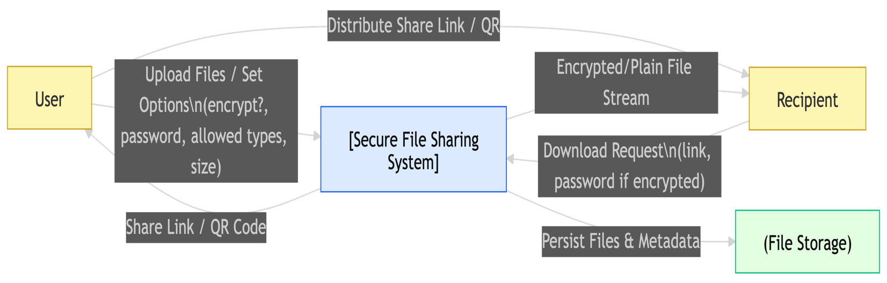

OVERALL PROCESSING FLOW
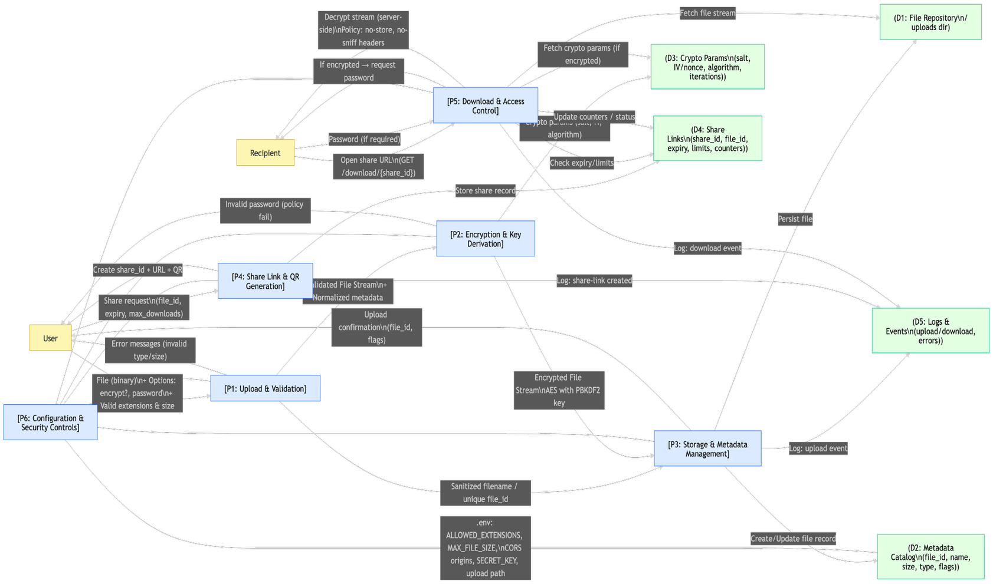

SAMPLE CODE:

import React, { useState, useEffect } from 'react';
import { useParams } from 'react-router-dom';
import axios from 'axios';
import './DownloadPage.css';

interface ShareInfo {
share_id: string;
filename: string;
is_encrypted: boolean;
file_size: number;
expiry_time: string;
is_expired: boolean;
max_downloads: number;
download_count: number;
downloads_remaining: number;
}

const DownloadPage: React.FC = () => {
const { shareId } = useParams<{ shareId: string }>();
const [shareInfo, setShareInfo] = useState<ShareInfo | null>(null);
const [password, setPassword] = useState('');
const [loading, setLoading] = useState(true);
const [error, setError] = useState('');
const [downloading, setDownloading] = useState(false);

const formatFileSize = (bytes: number): string => {
if (bytes === 0) return '0 Bytes';
const k = 1024;
const sizes = ['Bytes', 'KB', 'MB', 'GB'];
const i = Math.floor(Math.log(bytes) / Math.log(k));
return parseFloat((bytes / Math.pow(k, i)).toFixed(2)) + ' ' + sizes[i];
};

useEffect(() => {
fetchShareInfo();
}, [shareId]);

const fetchShareInfo = async () => {
try {
const response = await axios.get(`http://localhost:8000/share-info/${shareId}`);
setShareInfo(response.data);

if (response.data.is_expired) {
setError('This share link has expired');
} else if (response.data.downloads_remaining <= 0) {
setError('Download limit has been reached for this file');
}
} catch (error: any) {
if (error.response?.status === 404) {
setError('Invalid share link');
} else {
setError('Unable to load share information');
}
} finally {
setLoading(false);
}
};

const downloadFile = async () => {
if (!shareId) return;

setDownloading(true);
setError('');

try {
const url = `http://localhost:8000/download/${shareId}`;
const params = password ? { password } : {};

const response = await axios.get(url, {
params,
responseType: 'blob', // Important: get response as blob
headers: {
'Accept': 'application/octet-stream'
}
});

// Create blob from response data
const blob = new Blob([response.data], {
type: response.headers['content-type'] || 'application/octet-stream'
});

// Get filename from Content-Disposition header or use share info
let filename = 'download';
const contentDisposition = response.headers['content-disposition'];

if (contentDisposition) {
const filenameMatch = contentDisposition.match(/filename[^;=\n]*=((['"]).*?\2|[^;\n]*)/);
if (filenameMatch && filenameMatch[1]) {
filename = filenameMatch[1].replace(/['"]/g, '');
}
} else if (shareInfo?.filename) {
filename = shareInfo.filename;
}

// Create download link and trigger download
const downloadUrl = window.URL.createObjectURL(blob);
const link = document.createElement('a');
link.href = downloadUrl;
link.download = filename;
link.style.display = 'none';
document.body.appendChild(link);
link.click();

// Clean up
document.body.removeChild(link);
window.URL.revokeObjectURL(downloadUrl);

console.log('Download completed successfully');
setError('');
} catch (error: any) {
console.error('Download error:', error);
if (error.response?.status === 400) {
setError('Password required or incorrect password');
} else if (error.response?.status === 404) {
setError('File not found or share link invalid');
} else if (error.response?.status === 410) {
setError('Share link has expired');
} else if (error.response?.status === 429) {
setError('Download limit exceeded');
} else {
setError('Download failed. Please try again.');
}
} finally {
setDownloading(false);
}
};

if (loading) {
return (
<div className="download-page">
<div className="download-container">
<div className="loading">
<div className="spinner"></div>
<p>Loading share information...</p>
</div>
</div>
</div>
);
}

return (
<div className="download-page">
<div className="download-container">
<div className="download-header">
<h1>🔐 Secure File Download</h1>
<p>You've been shared a secure file</p>
</div>

<div className="download-form">
<div className="share-info">
<div className="file-icon">
{shareInfo?.is_encrypted ? '🔒' : '📄'}
</div>
<h3>{shareInfo?.filename || 'Shared File'}</h3>
<p>File Size: {shareInfo?.file_size ? formatFileSize(shareInfo.file_size) : 'Unknown'}</p>
<p>Downloads Remaining: {shareInfo?.downloads_remaining || 0}</p>
<p>Expires: {shareInfo?.expiry_time ? new Date(shareInfo.expiry_time).toLocaleString() : 'Unknown'}</p>
<small>Share ID: {shareId}</small>
</div>

{shareInfo?.is_encrypted && (
<div className="password-section">
<label>
<span>🔑 Password Required:</span>
<input
type="password"
placeholder="Enter password to decrypt file"
value={password}
onChange={(e) => setPassword(e.target.value)}
onKeyPress={(e) => e.key === 'Enter' && downloadFile()}
/>
</label>
</div>
)}

<button
className="download-btn"
onClick={downloadFile}
disabled={downloading || !!error || (shareInfo?.is_encrypted && !password)}
>
{downloading ? (
<>
<div className="btn-spinner"></div>
Downloading...
</>
) : (
<>
💾 Download {shareInfo?.filename || 'File'}
</>
)}
</button>

{error && (
<div className="error-message">
❌ {error}
</div>
)}

<div className="security-note">
<p>🛡️ This file is shared securely with encryption and access controls</p>
</div>
</div>

<div className="back-link">
<a href="/">← Back to File Sharing</a>
</div>
</div>
</div>
);
};

export default DownloadPage;

SAMPLE INPUT

Home Page:

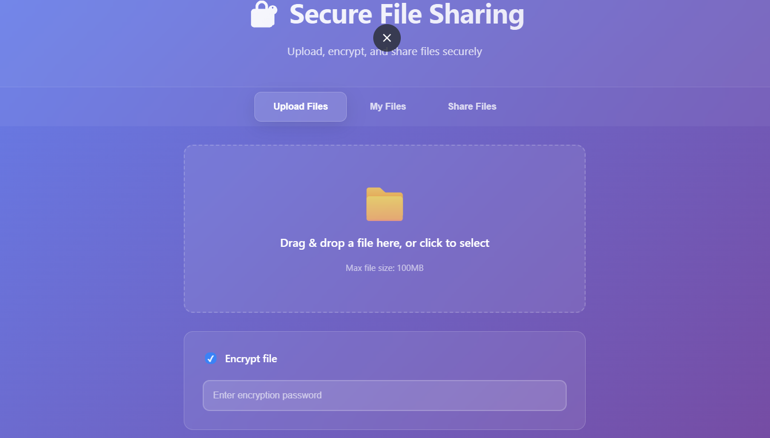

Files Page:
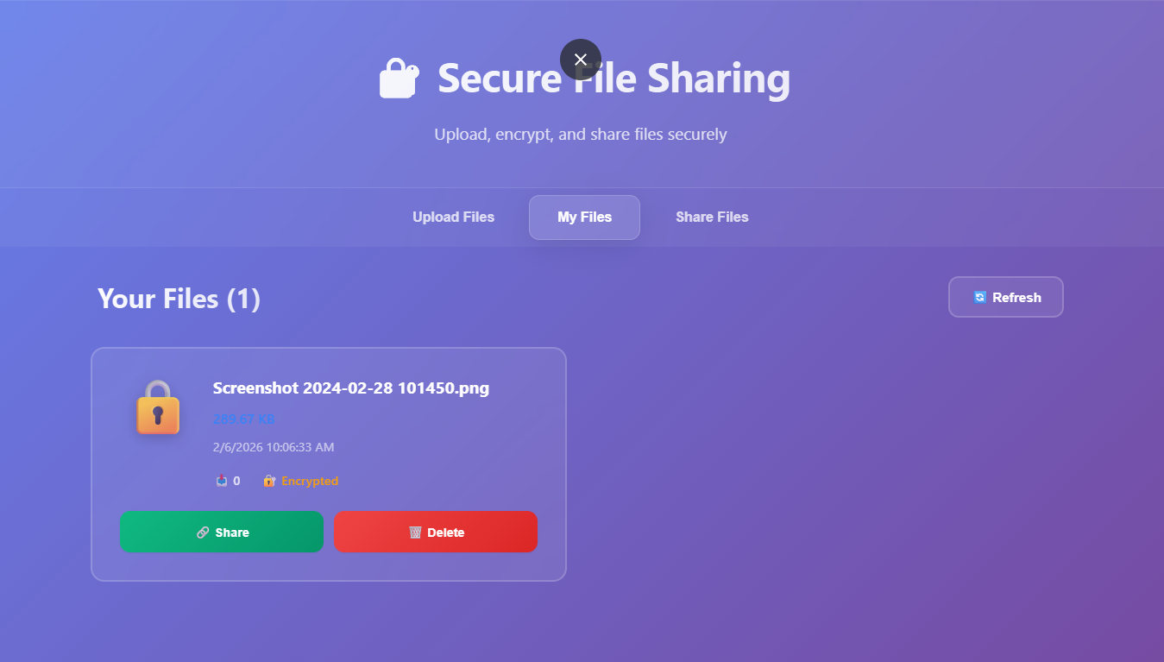

File Sharing Page

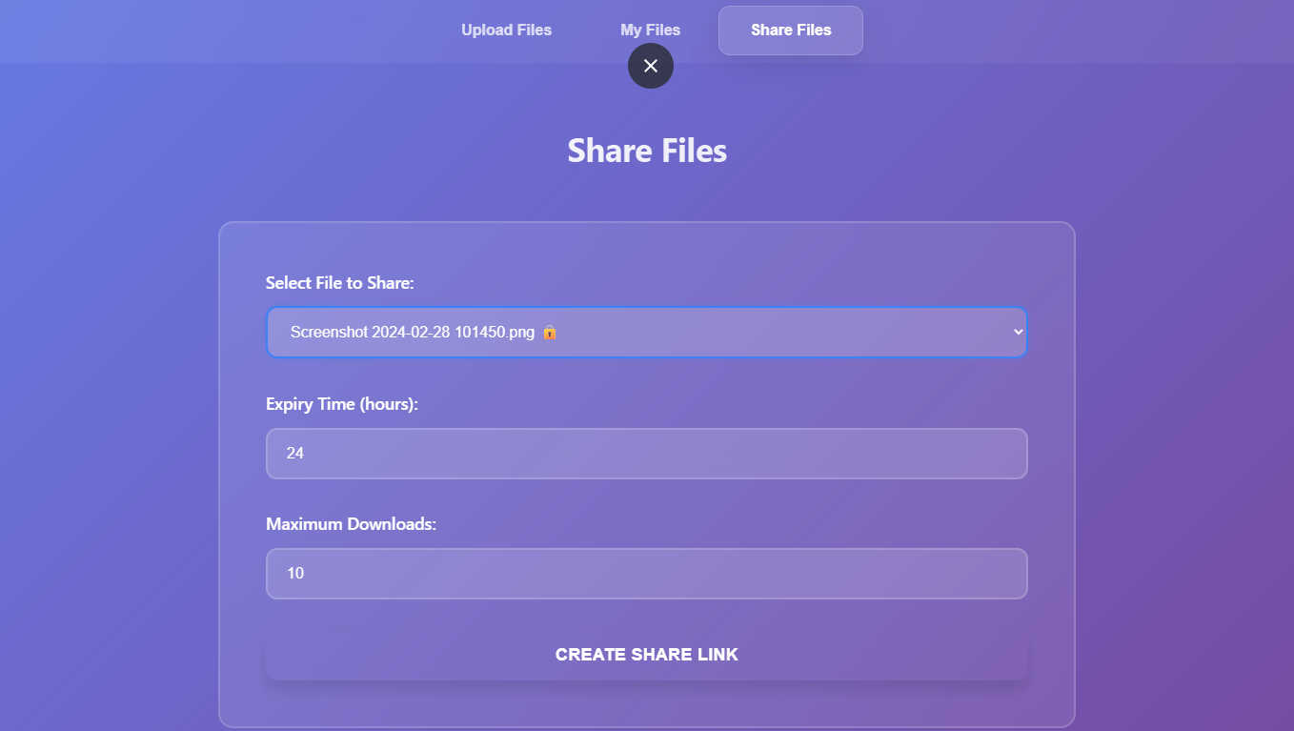

SAMPLE OUTPUT:

Shared QR Page:

